**Muscular System – Notes**

The muscular system is organised to maintain posture and produce movement; muscle fibre contraction can be explained using the sliding filament theory.

3 properties allow muscles to work together to create movement:

1. Contractibility – The ability to contract.
2. Extensibility – The ability to be stretched.
3. Elasticity – The ability to return to the original length after being stretched.

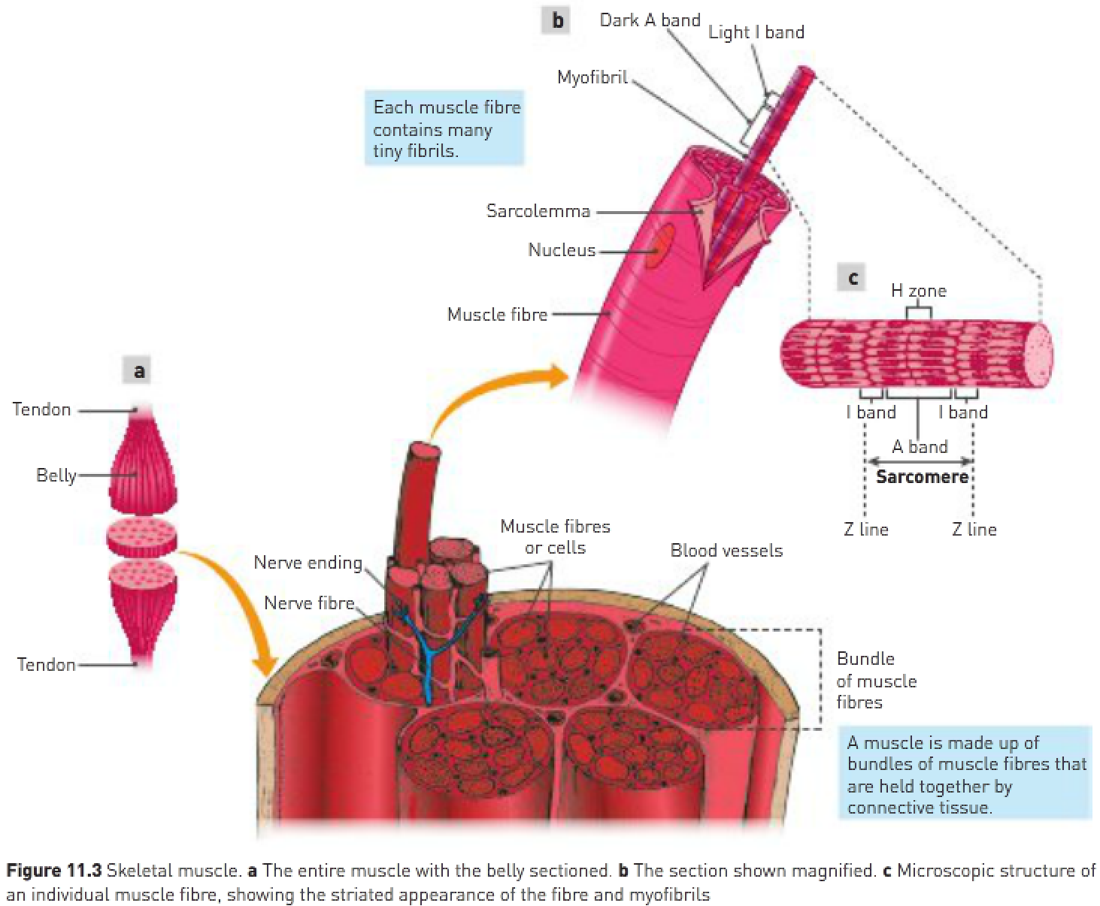

* The amount of connective tissue increases with advancing age.
* Each muscle cell is an elongated cylinder with many nuclei.
* Around the cell is a thin, transparent plasma membrane, called the sarcolemma, containing cytoplasm, called the sarcoplasm.
* These cylindrical cells are called muscle fibres.
* Within the sarcoplasm of each fibre there are thread-like myofibrils lying parallel to each other and running along the length of the fibre.

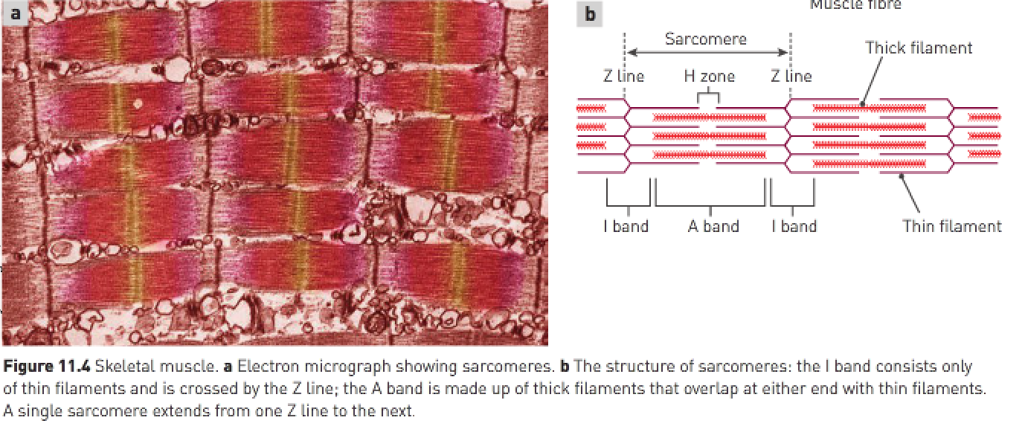

Structure of myofibrils:

* The myofibrils are composed of many smaller myofilaments made of protein, which are the units involved in contraction of muscle.
* There are 2 types of myofilaments:

1. Thin myofilaments (composed of the protein actin).

2. Thick myofilaments (composed of the protein myosin).

* When a muscle fibre is supplied with sufficient energy and is activated by a nerve impulse, these thick and thin protein filaments slide past each other in a manner that shortens the myofibril.
* Myofibrils can be divided into units called sarcomeres.
* The striated appearance of skeletal muscle is due to variations in the actin and myosin content in different parts of the sarcomere.



Sliding filament theory:

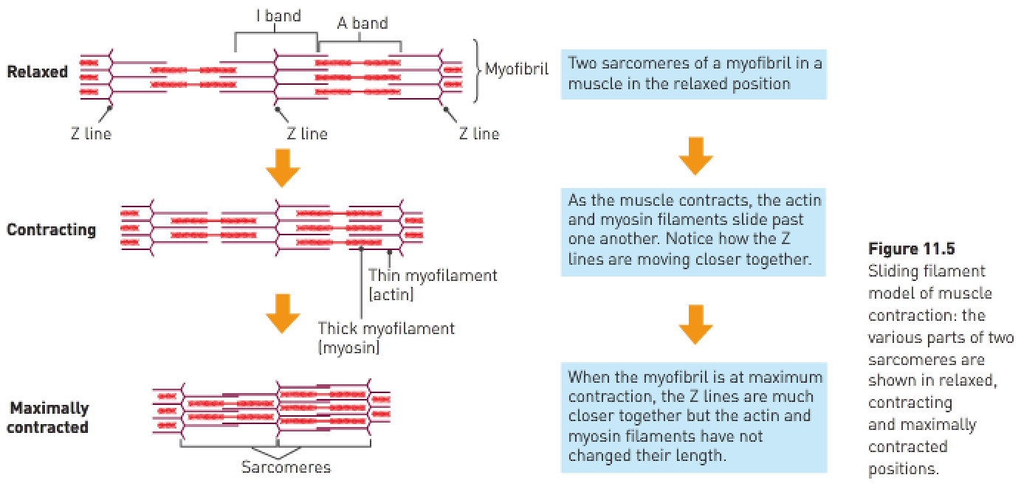

* As the thin actin filaments slide over the thick myosin filaments, the Z lines are drawn closer together and the sarcomere is shortened.
* The fibril has shortened because the myofilaments overlap more.
* The energy required for shortening of the muscle fibres comes from the breakdown of ATP in the muscle cells.
* Energy is released when ATP breaks down to ADP+P.

Sliding filament theory:

1. A nerve impulse reaches the bundle of muscle fibres and triggers the release of calcium from the sarcoplasmic reticulum.
2. The calcium binds to the actin myofilaments and this causes the myosin binding sites to be exposed to the myosin.
3. The myosin myofilament joins to the myosin binding sites on the actin and forms crossbridges.
4. The formation of crossbridges requires energy (ATP).
5. The myosin crossbridges pull on the actin and the actin slides over the myosin (note: myosin doesn’t change in length). This also requires ATP and is the muscle-shortening phase of muscular contraction. This is called downstroke.
6. Z-lines move close together / sarcomere shortens.
7. It requires ATP to cause the myosin to “unhook” off the binding sites. Once the crossbridges move off the binding sites, the actin slides back to the “resting” position. Z-lines move further apart / sarcomere lengthens.

* Muscles are attached to the bones of the skeleton by fibrous, inelastic connective tissue called tendons.
* Coordination of the paired muscles provides body movement, with one air producing movement of bones in one direction and the other producing movement in the opposite direction – such pairs are referred to as antagonists.

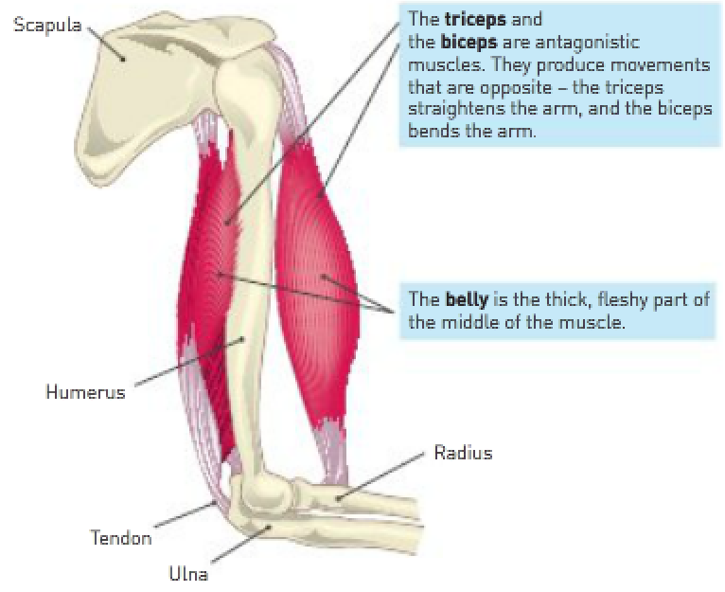

**Origin**: The end of the muscle fixed to the stationary bone.

**Insertion**: The attachment of the other end of the muscle, to the moveable bone.

**Belly**: The fleshy portion of the muscle between the tendons of the origin and the insertion.

**Agonist (prime mover)**: A muscle that causes a desired action.

**Antagonist**: A muscle that has the opposite effect of the desired action.

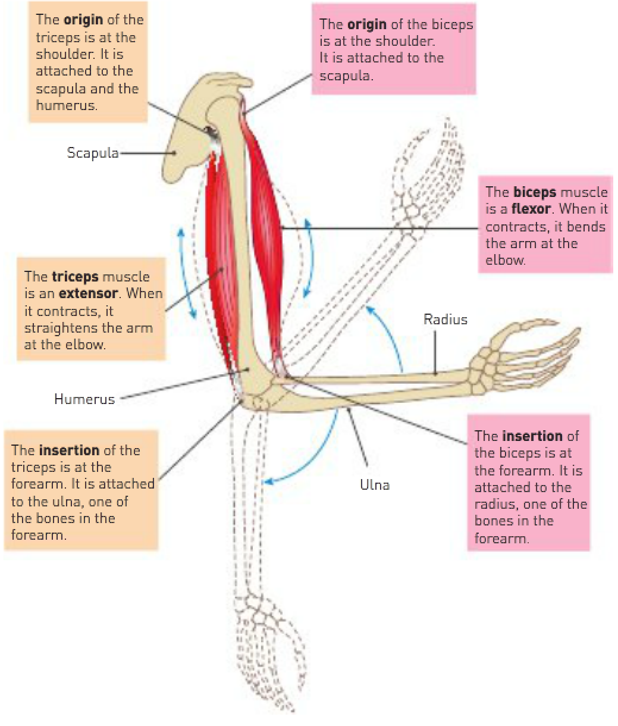

**Synergists**: Muscles that help the prime mover.

**Fixator**: A synergist that immobilises a joint to prevent unwanted movement.

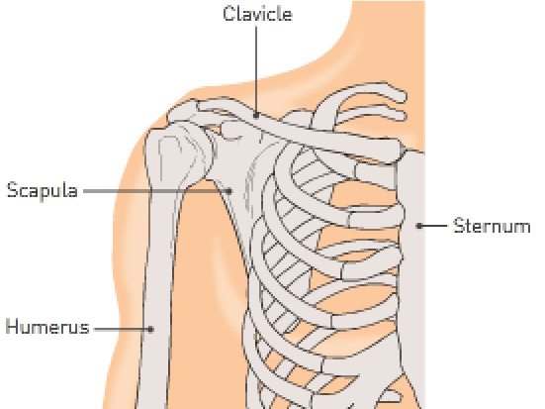

Synergists:

* May produce the same movement as the prime mover or they may steady a joint during a particular movement so that unwanted movement is prevented.
* The same muscle may at different times be an agonist, antagonist or synergist.

Muscle tone:

* Maintaining partial contraction of skeletal muscles.
* At any one time, some muscle fibres are contracted while others are relaxed.
* Not caused by the constant contraction of the same fibres, but by many different fibres taking turns to contract.

Posture: The characteristic way a person holds their body when standing or sitting.